EcoTEA Workbench (Strata)
Project Technical Final Report
March – August 2026
Team 15 · A*STAR Internship (SIMTech)
Team Members: Zhang Yuchen (A0297541W) · Fan Yazhuoting (A0287202J)
Repository: github.com/DawnZYC/DBDesign
AI Tool Declaration: I used GPT-5.4, Claude to refine the wording, improve the clarity of expression, assist in identifying and fixing code bugs, and generate some images and illustrations used in this assignment. I am responsible for the content and quality of the submitted work.

Scope of This Report
This final report documents the EcoTEA Workbench (internally code-named Strata) as implemented at the end of the internship, covering both Phase 1 (data pipeline automation, March – May 2026) and Phase 2 (the AI-powered analysis platform, June – August 2026). Whereas the midterm report described Phase 2 as a plan, every capability discussed here — the LLM provider registry, the ChromaDB RAG layer, the six function-calling tools, the LangGraph multi-agent pipeline with SSE streaming, the chat interface with ECharts visualisation and cell-level provenance, and the hardened DevSecOps pipeline — is implemented in the repository and exercised by automated tests and CI workflows. Following the final-presentation guidelines, the report is organised into six sections: the architecturally significant use case with its analysis- and design-level models (Section 1), the CI/CD pipeline (Section 2), unit and integration testing (Section 3), and management, technical, and security concerns with their mitigations (Sections 4 – 6). All claims are backed by artefacts in the repository (source files, workflow definitions, test suites, and security documents), which are cited by path throughout.

1. Key Use Case — UC11: Ask a Question in Natural Language

1.1 Functional Overview
The functional scope of the delivered system is summarised by two use case diagrams maintained in docs/diagrams/. The system-level diagram (Figure 1.1) shows the overall boundary: the researcher interacts with the platform through the Convert, Import, and Browse workflows delivered in Phase 1 and the AI-assisted analysis workflows delivered in Phase 2, while the PostgreSQL database, the ChromaDB vector store, and external LLM providers appear as system actors. The detailed diagram (Figure 1.2) breaks the scope down into individual use cases; the Phase 2 use cases that were only planned at midterm — querying technology data in natural language, generating forecasts, visualising trends with ECharts, and auto-mapping new Excel formats to the database schema — are now implemented.
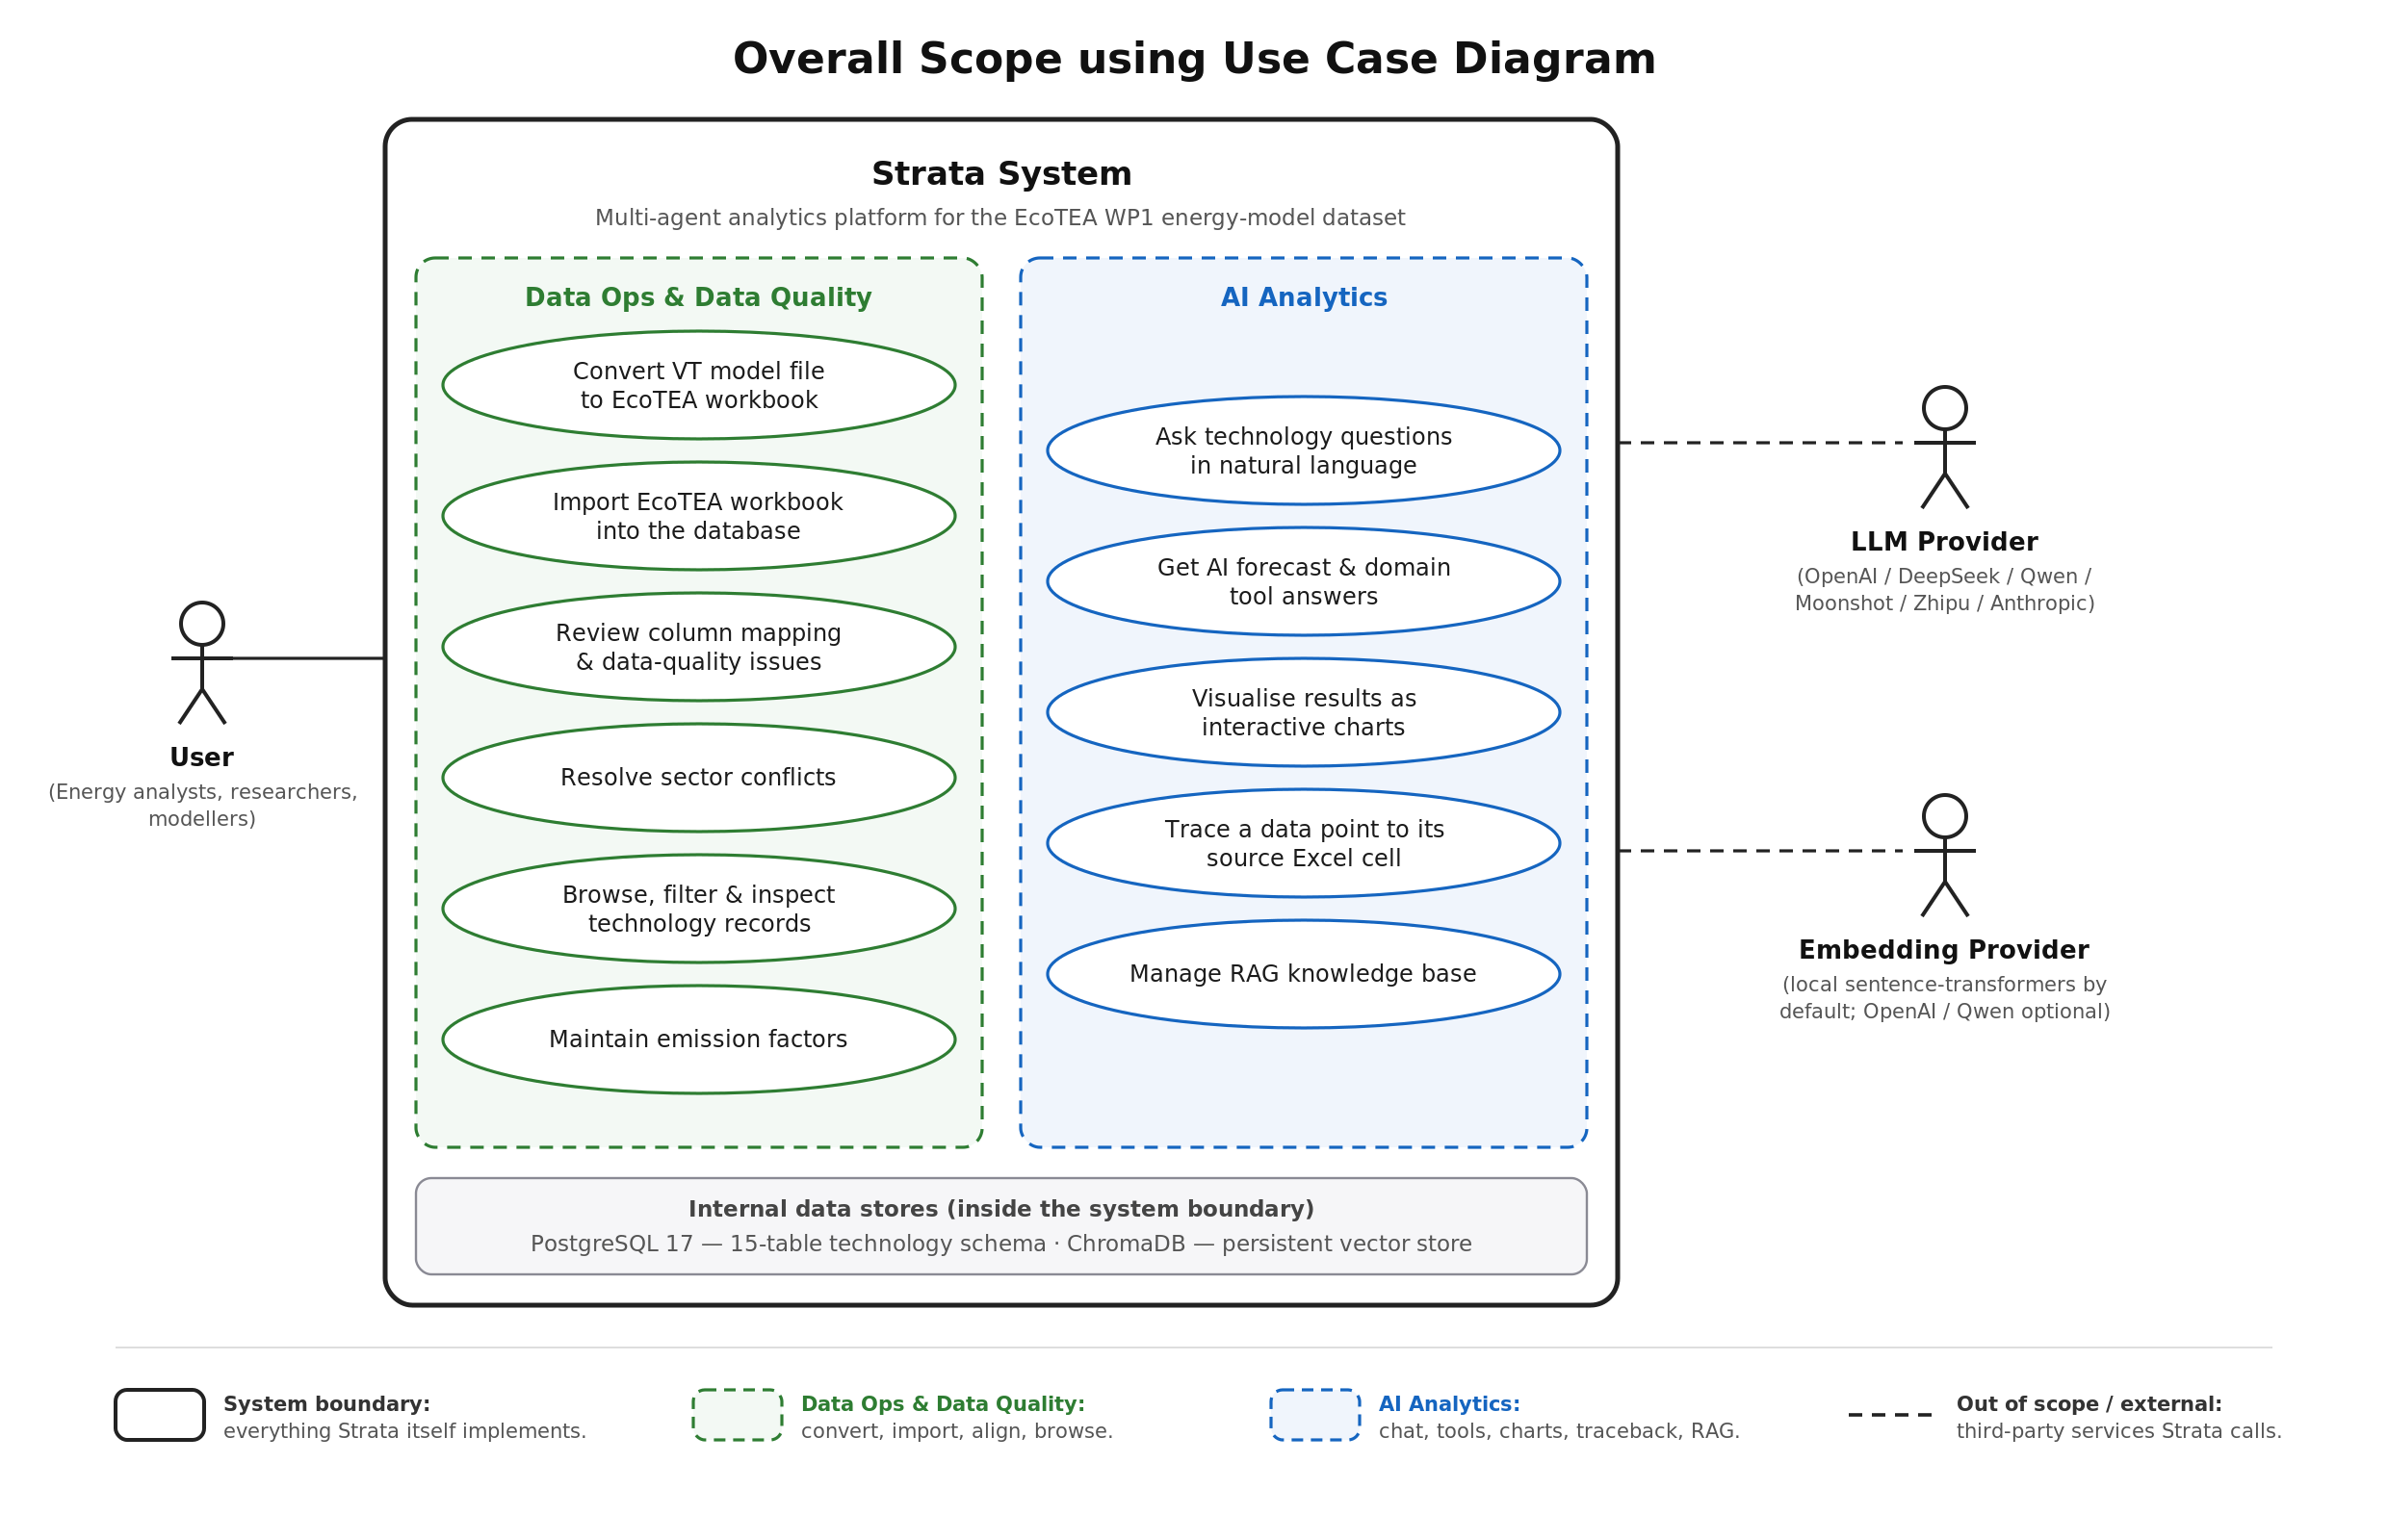
Figure 1.1: System-level use case diagram (docs/diagrams/01_overall_scope_use_case.svg)
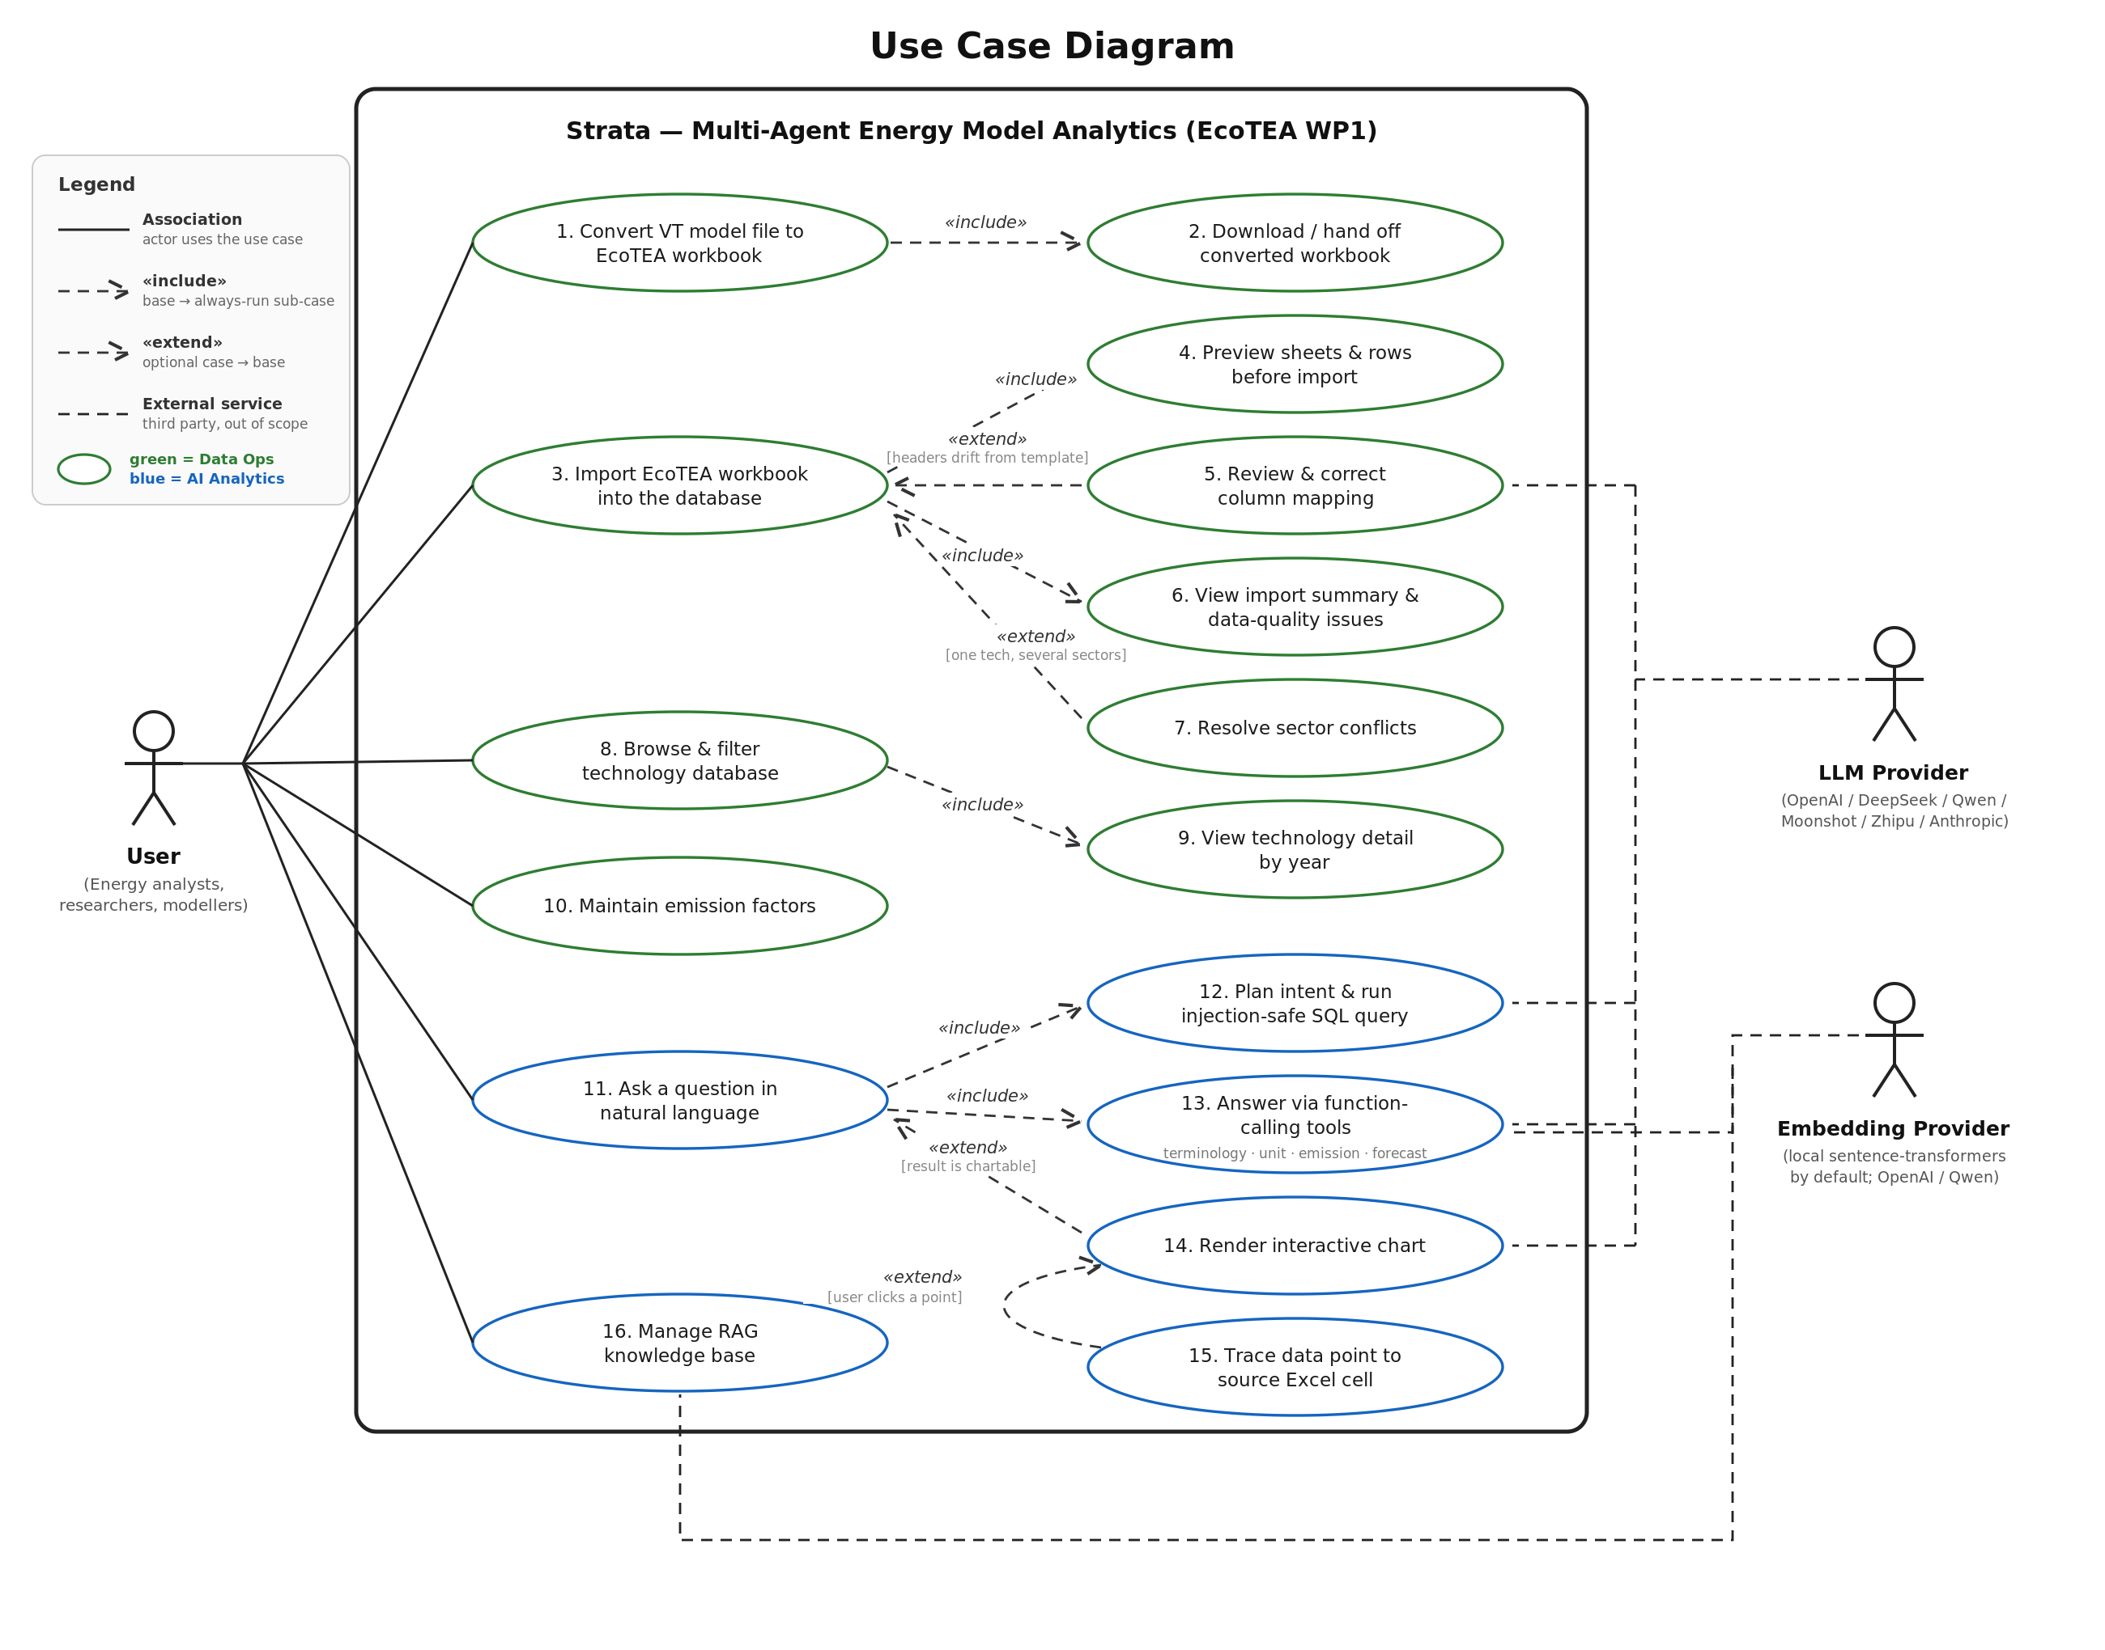
Figure 1.2: Detailed use case diagram (docs/diagrams/02_use_case_diagram.svg)

1.2 Why UC11 Is Architecturally Significant
UC11, “Ask a question in natural language”, is selected as the architecturally significant use case for the final review because it exercises every layer of the delivered system simultaneously: the React chat view and its streaming view-model, the SSE transport, the LangGraph orchestration of four specialised agents, the function-calling tool library, injection-safe data access over the 14-table PostgreSQL schema, the ChromaDB RAG layer, and the provider-agnostic LLM registry. It also realises the project's central provenance requirement — every figure shown to the researcher can be traced back to the exact workbook cell it came from. The full object-oriented analysis and design walkthrough for this use case is versioned in docs/diagrams/UC11_analysis_to_design.md together with the four diagrams reproduced below.

1.3 Analysis Model
The analysis model deliberately uses only the analyst's vocabulary: there is no controller, service, repository, HTTP, LLM, or database in it. The analysis class diagram (Figure 1.3) captures sixteen domain classes — Conversation, Question, Intent, AnalysisPlan, QuerySpecification, Metric, AnswerSet, DataPoint, SourceCell, Technology, TechnologyYear, Sector, Geography, Insight, Chart, and KnowledgeDocument — with attributes and associations only. The key invariant is the one-to-one association DataPoint — SourceCell: every data point the platform shows is traceable to a single workbook cell. This one association later forces raw_row_id through the query result, the chart dataset, and the trace endpoint in the design model.
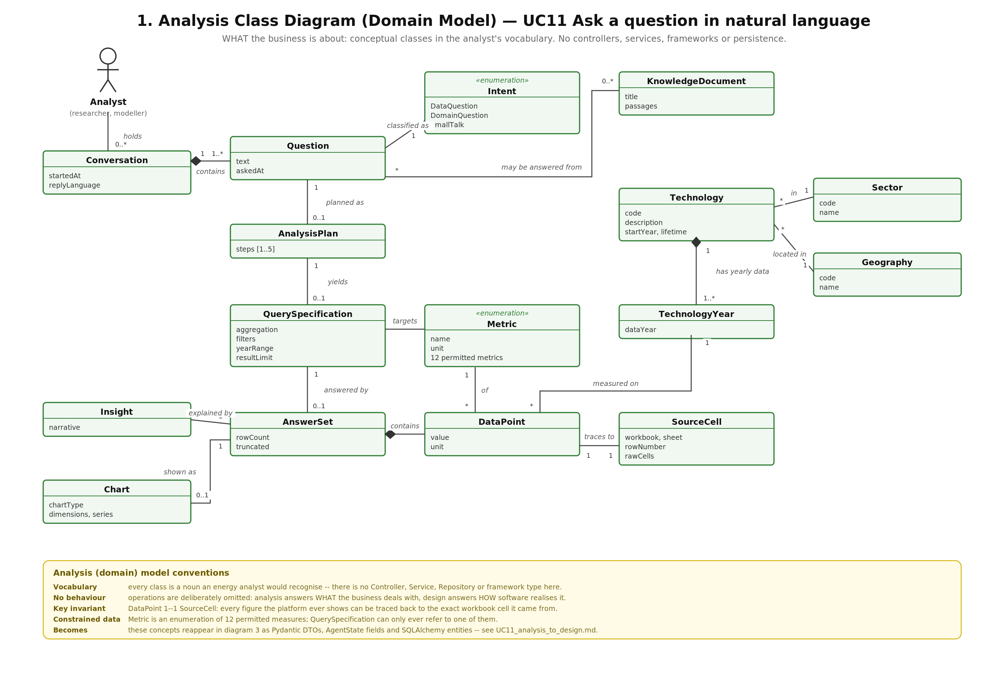
Figure 1.3: UC11 analysis class diagram (domain model)
The analysis sequence diagram (Figure 1.4) describes the business process: the analyst asks; the platform understands the question, retrieves data or consults domain knowledge, explains the result, optionally charts it, and on request reveals provenance. At this level the system is a single black box and the four workers (question understanding, data retrieval, insight generation, visualisation) are business capabilities, not classes.
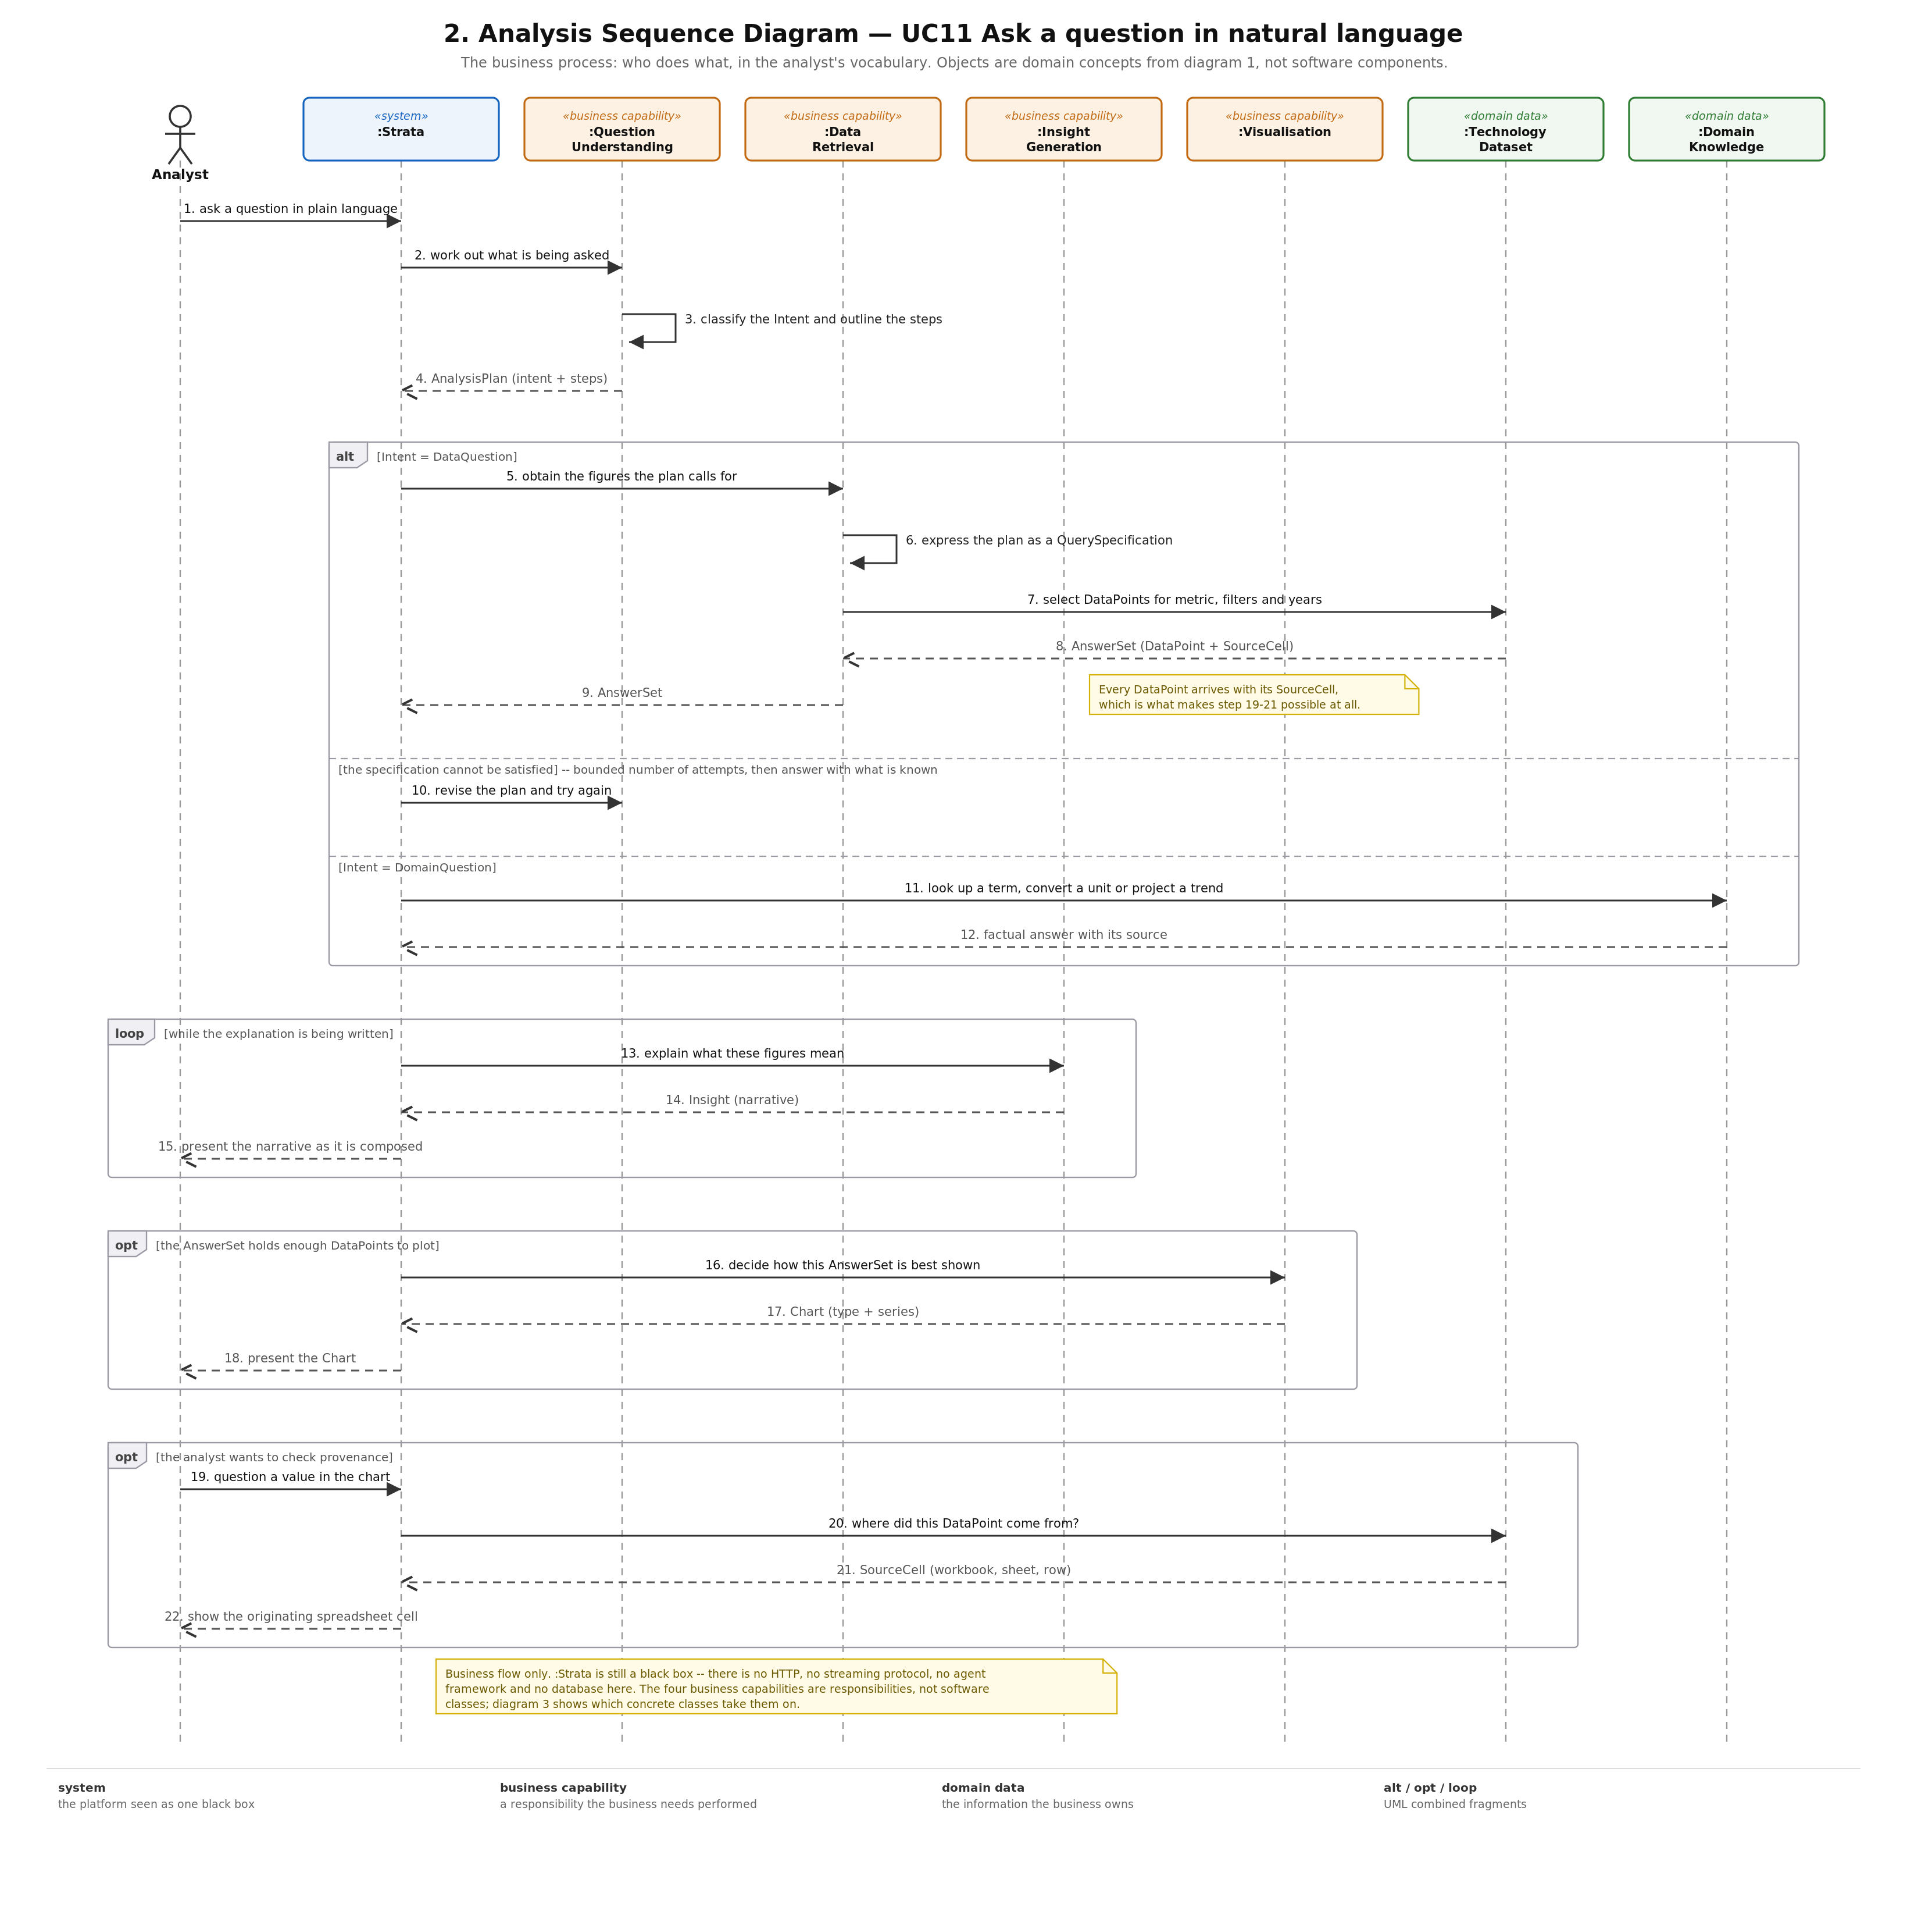
Figure 1.4: UC11 analysis sequence diagram (business process)

1.4 Transition from Analysis to Design
Every design element traces back to an analysis element. The table below maps each domain object to the software type that realises it and the file where it lives, demonstrating how the use case is implemented across the frontend, backend, and communication frameworks (React, FastAPI, LangGraph, SSE).
Analysis (domain model) | Design (software) | File
Question, Conversation | ChatRequest.message / .history; AgentState.messages | app/routers/chat.py, app/agents/state.py
Intent «enumeration» | AgentState.intent + _parse_intent() | app/agents/planner.py
AnalysisPlan | AgentState.plan: list[str] | app/agents/state.py
QuerySpecification | QueryParams (Pydantic DTO) | app/tools/sql_runner.py
Metric «enumeration» | MetricName Literal + METRICS registry | app/tools/sql_runner.py
AnswerSet | QueryResult (Pydantic DTO) | app/tools/sql_runner.py
DataPoint | Row in QueryResult.rows carrying raw_row_id | app/tools/sql_runner.py
SourceCell | RawRow entity + GET /api/raw-rows/{id} | app/models.py, app/routers/raw_rows.py
Technology, TechnologyYear, Sector, Geography | SQLAlchemy ORM entities | app/models.py
Insight | AgentState.interpretation (streamed) | app/agents/interpreter.py
Chart | AgentState.chart_spec (ECharts option) | app/agents/visualizer.py
KnowledgeDocument | ChromaDB collection + lookup_terminology | app/rag/, app/tools/terminology.py

The business capabilities of the analysis model map onto a layered software structure: the black box :Strata splits into a controller (chat.py::chat_stream, which turns graph events into SSE) and an application-level orchestrator (the compiled LangGraph state machine in graph.py); :QuestionUnderstanding becomes the planner_node service; :DataRetrieval becomes sql_agent_node backed by the run_sql repository; :InsightGeneration becomes interpreter_node; :Visualisation becomes visualizer_node with the recommend_chart policy; and :DomainKnowledge becomes tool_agent_node over the AUX_TOOLS registry. On the frontend, the analyst's screen is realised as the ChatPage / ChartBubble views, the useStreamChat view-model, and the streamChat() gateway.

1.5 Design Model
The design class diagram (Figure 1.5) shows the resulting class-level structure across view, controller, application, domain service, repository, and infrastructure layers; the design sequence diagram (Figure 1.6) shows how the software actually calls itself at object level, from the browser's fetch-based SSE reader through the FastAPI endpoint, the LangGraph nodes, the SQL tool, and back out as a progressive event stream.
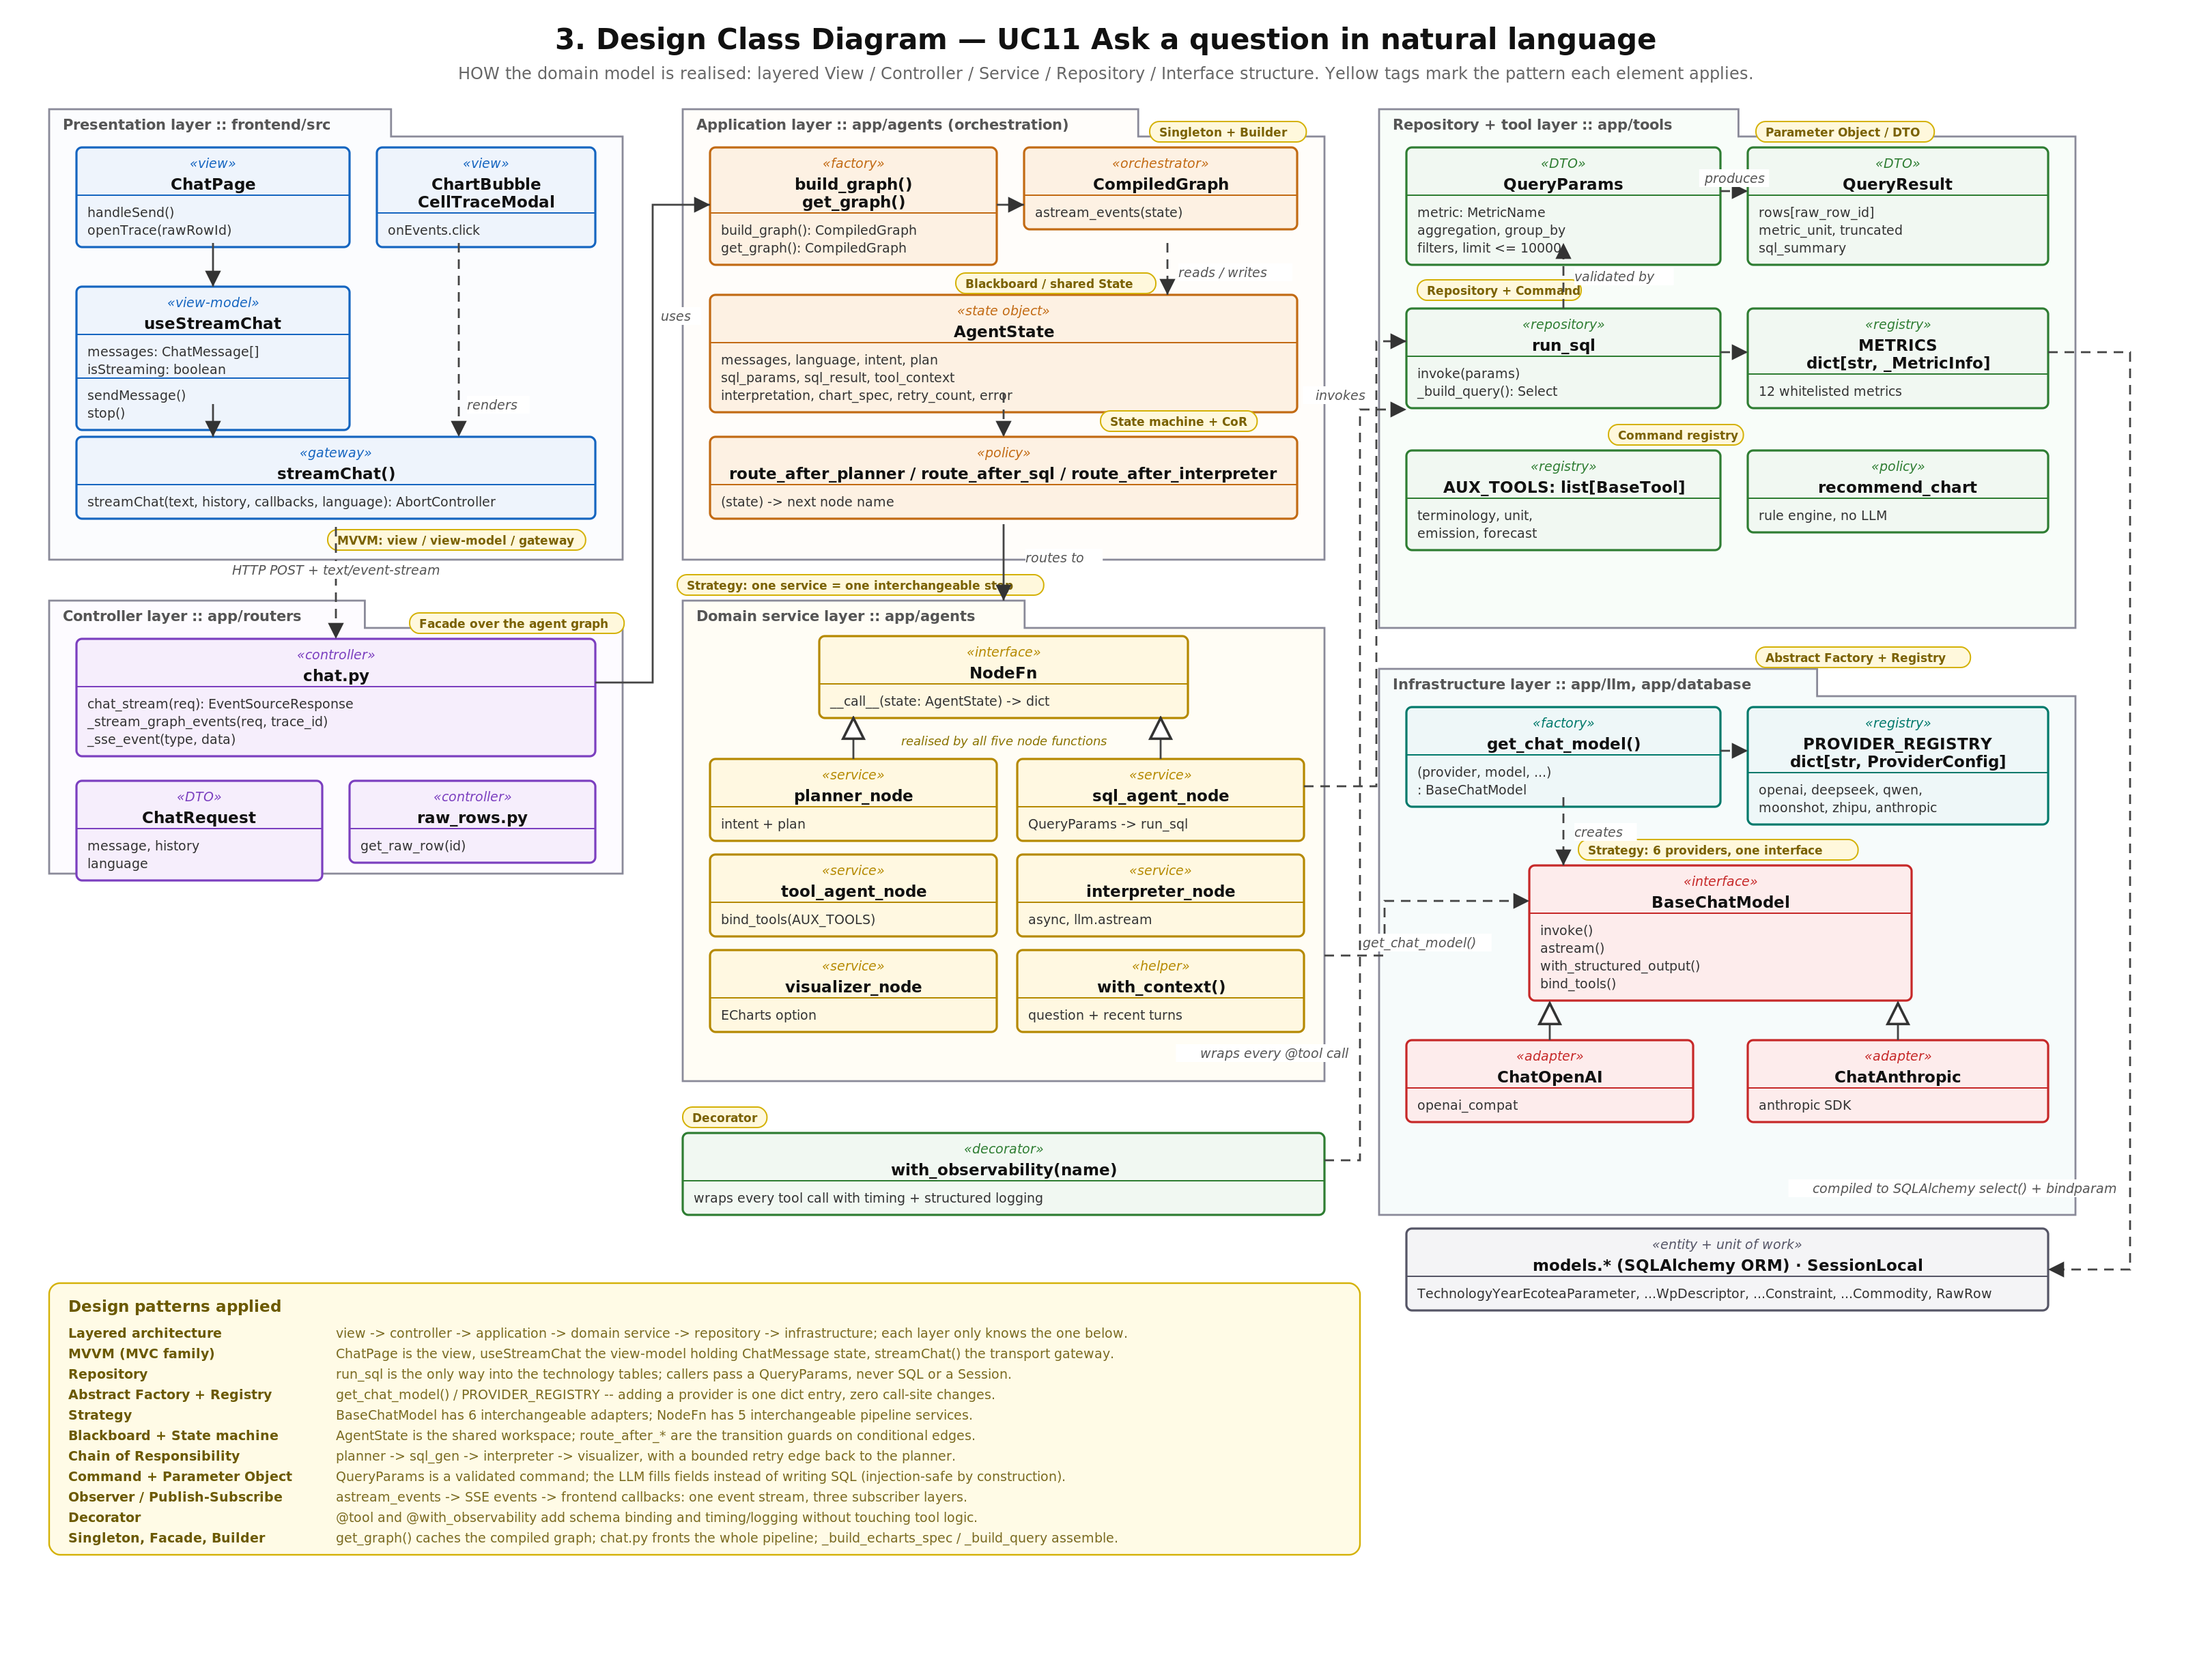
Figure 1.5: UC11 design class diagram (view / controller / service / repository / interface layers)
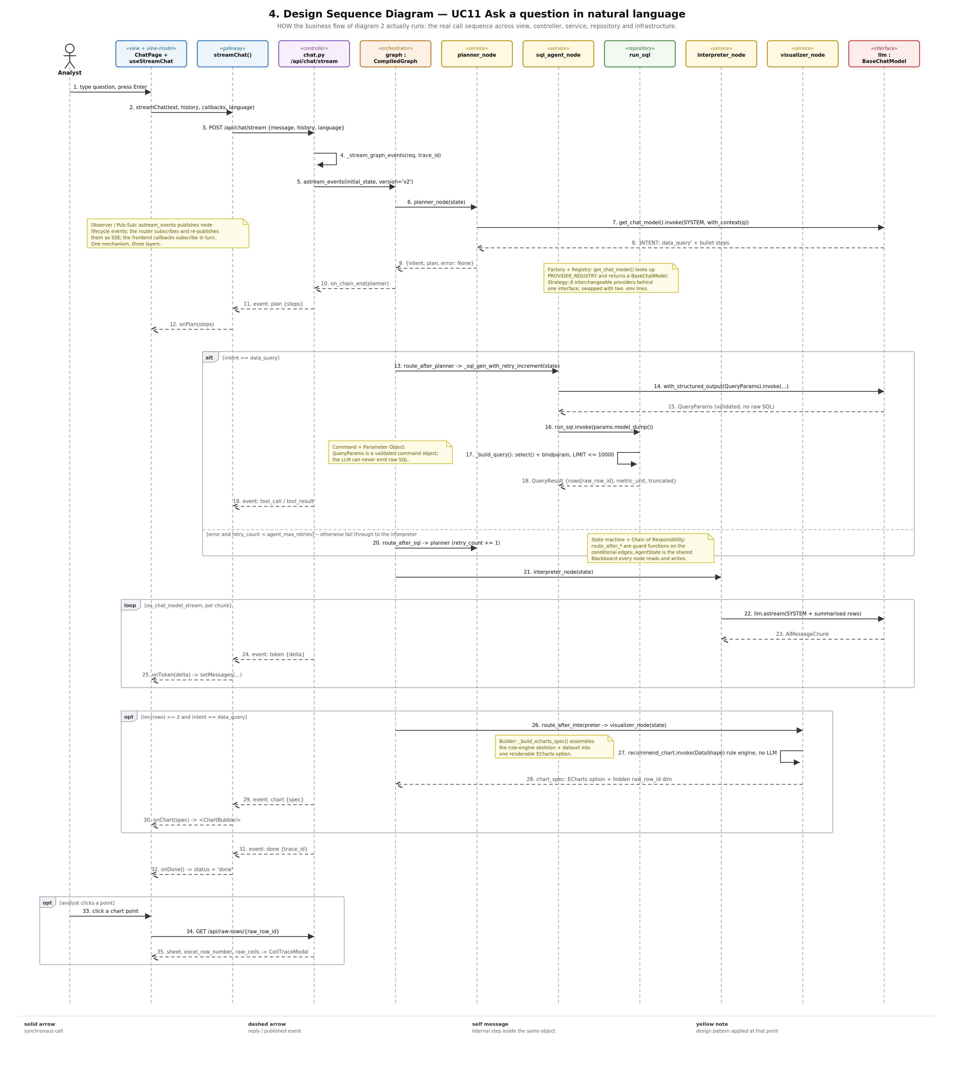
Figure 1.6: UC11 design sequence diagram (class/object level, including SSE streaming)
Five decisions exist only in the design model and illustrate the analysis-to-design refinement. First, the sixteen domain classes collapse into a single AgentState TypedDict — a Blackboard — because LangGraph requires one state object flowing between nodes; the domain boundaries survive as field groups. Second, the analysis black box splits into transport (chat.py) and control flow (graph.py), so the pipeline is testable with no HTTP involved. Third, “express the plan as a QuerySpecification” becomes typed structured output: llm.with_structured_output(QueryParams) lets the LLM fill only whitelisted fields, which _build_query() compiles into a parameterised SQLAlchemy select(); the model is structurally prevented from producing SQL at all. Fourth, the request/response interaction of the analysis model becomes streaming: llm.astream() events are converted to SSE token events consumed by the useStreamChat hook, so the answer forms progressively in front of the user. Fifth, the DataPoint — SourceCell invariant is realised as a hidden chart dimension: raw_row_id is kept in every query row, carried into the ECharts dataset, and resolved by GET /api/raw-rows/{id} when the user clicks a data point.

1.6 Design Patterns and Their Effect on the Architecture
The design applies a deliberate set of patterns, each purchased for a specific maintainability property. The most consequential are summarised below; the full catalogue is documented in docs/diagrams/UC11_analysis_to_design.md.
Pattern | Where it lives | What it buys
Layered architecture | view → controller → application → service → repository → infrastructure | The agent pipeline can be exercised without a browser, and the repository without an LLM.
MVVM | ChatPage (view), useStreamChat (view-model), streamChat() (gateway) | The SSE protocol can change without touching a component.
Repository | run_sql over models.* / SessionLocal | The only door into the technology tables; no caller holds a Session or writes SQL.
Abstract Factory + Registry | get_chat_model() over PROVIDER_REGISTRY; same shape in rag/embeddings.py | Adding a seventh LLM provider is one dict entry plus one settings field.
Blackboard | AgentState | Four specialist services contribute partial results to one shared workspace.
State machine / Chain of Responsibility | route_after_planner / route_after_sql / route_after_interpreter | Intent branching and bounded retry are pure functions, unit-testable with no LLM.
Command + Parameter Object | QueryParams | The command is data: validatable, loggable, and structurally incapable of expressing SQL injection.
Observer (publish–subscribe) | astream_events → SSE → frontend callbacks | One event stream, three subscriber layers; the tool-call trace UI needed no backend change.
Facade | POST /api/chat/stream | One endpoint hides planner, SQL agent, tool agent, interpreter, and visualizer from every client.
Builder | _build_query() → Select; _build_echarts_spec() → ECharts option | Complex objects assembled from many optional parts; construction separated from parts.

2. CI/CD Pipeline

2.1 Pipeline Overview
The project's delivery pipeline has grown from the two-workflow setup described at midterm into six GitHub Actions workflows that together cover continuous integration, security scanning, container publication, continuous deployment, performance testing, and dynamic application security testing. Figure 2.1 shows the complete pipeline: ci.yml acts as a six-job blocking quality gate on every pull request and push to main; build-images.yml builds, scans, and publishes container images; deploy.yml implements an “environment-ready” continuous deployment design; and load-test.yml and dast.yml run as scheduled or on-demand side pipelines.
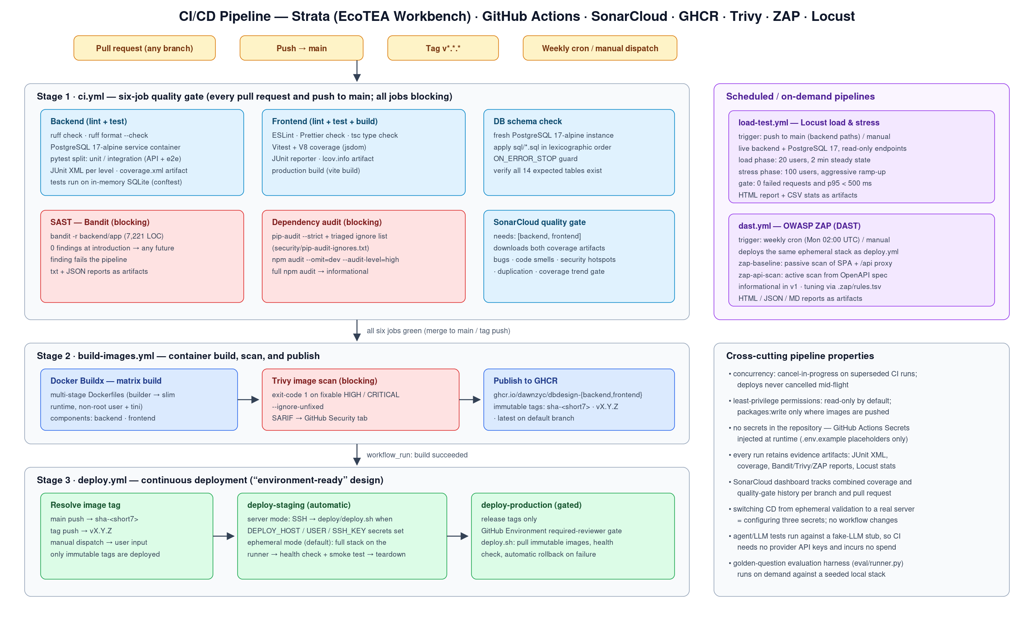
Figure 2.1: CI/CD pipeline — six GitHub Actions workflows (.github/workflows/)

2.2 ci.yml — Six-Job Blocking Quality Gate
The Backend job runs ruff lint and format checks, starts a PostgreSQL 17-alpine service container, applies all SQL migrations, and executes the pytest suite in two separately reported runs: a unit run (everything except API-level tests) and an integration run (the six router test modules exercised over HTTP via FastAPI's TestClient plus the Excel importer end-to-end flow). Each run produces its own JUnit XML artifact (junit-unit.xml, junit-integration.xml) and the combined coverage.xml is uploaded for SonarCloud. The Frontend job runs ESLint, Prettier, and the TypeScript compiler, executes Vitest with V8 coverage and a JUnit reporter, and performs a production build. The DB schema check job applies sql/*.sql in lexicographic order against a fresh PostgreSQL 17 instance with ON_ERROR_STOP and verifies that all expected tables exist — a schema regression guard independent of the application test suite.
Three further jobs complete the gate. SAST (Bandit) scans backend/app and fails the pipeline on any finding; the scan was clean (0 findings across 7,221 lines) when the job was introduced as blocking, so any future finding must be fixed or explicitly waived with a justified # nosec comment. The Dependency audit job is blocking since the 2026-07-22 triage: pip-audit runs in strict mode with a versioned, justification-annotated ignore list (security/pip-audit-ignores.txt), and npm audit must be clean of high/critical findings for production dependencies, with a full informational audit for the dev-tooling chain. Finally, the SonarCloud quality gate job downloads both coverage artifacts and evaluates bugs, code smells, security hotspots, duplication, and coverage against the quality gate. Concurrency is configured with cancel-in-progress so superseded runs on the same ref are cancelled.

2.3 build-images.yml — Container Build, Scan, and Publication
On every push to main and on release tags, a fail-fast-disabled matrix builds the backend and frontend images from their multi-stage Dockerfiles (builder stage separated from a slim runtime with a non-root user and tini as PID 1). Images are pushed to the GitHub Container Registry under ghcr.io/dawnzyc/dbdesign-{backend,frontend}, tagged with the immutable short commit SHA, latest on the default branch, and the semver tag on releases. Trivy then scans the freshly built image digests; since the July hardening the scanner runs with exit-code 1 and --ignore-unfixed, so any fixable HIGH or CRITICAL CVE blocks publication, and SARIF results are uploaded to the GitHub Security tab.

2.4 deploy.yml — Continuous Deployment (Environment-Ready)
Continuous deployment follows an “environment-ready” design: the pipeline is fully wired even though the internship scope includes no permanently provisioned server. The workflow is triggered by workflow_run on a successful image build (or manually with an explicit tag and target). A resolve job derives the immutable image tag — sha-<short7> for main pushes, the semver tag for releases. deploy-staging then runs automatically in one of two modes decided by the presence of the DEPLOY_HOST secret: in server mode it connects over SSH and runs deploy/deploy.sh on the host (pull immutable images, health check, automatic rollback on failure); in ephemeral mode — the default — it brings the full stack up on the runner using the exact same compose file (deploy/docker-compose.deploy.yml) and script, health-checks and smoke-tests it, and tears it down, validating the entire deploy path end-to-end at zero infrastructure cost. deploy-production is reachable only from release tags and is additionally gated behind a GitHub Environment required-reviewer approval. Switching from ephemeral validation to a real server requires configuring three secrets and no code changes.

2.5 Scheduled Pipelines — Performance and DAST
load-test.yml runs Locust against a live backend with PostgreSQL 17, in two phases: a load phase (20 concurrent users, two minutes of steady state, matching expected traffic) and a stress phase (100 users with aggressive ramp-up as a breaking-point probe), restricted to read-only endpoints so no LLM spend or data mutation occurs. The workflow enforces explicit thresholds — zero failed requests and p95 latency below 500 ms in the load phase — and fails otherwise, uploading the HTML report and CSV statistics as artifacts. dast.yml deploys the same ephemeral stack used by deploy.yml and runs OWASP ZAP twice: a baseline passive scan of the SPA through nginx (which also exercises the /api reverse proxy) and an active API scan driven by the backend's OpenAPI specification. It runs weekly by cron and on demand; findings are informational in v1, with rule tuning versioned in .zap/rules.tsv and a documented plan to flip the gate to blocking once the baseline is triaged.

3. Unit Testing and Integration Testing

3.1 Testing Strategy
The test strategy follows a pyramid across both halves of the stack, with three deliberate architectural enablers. First, the converter module has zero imports from models.py or database.py, so all converter tests run with no database instance. Second, database-backed tests run on an in-memory SQLite schema built once per session in conftest.py, keeping the full backend suite runnable in seconds with no services; PostgreSQL-specific behaviour (JSONB, upsert syntax, the 14-table DDL) is guarded separately by the CI DB schema check job, which applies the real migrations against PostgreSQL 17 on every run. Third, all agent and LLM-dependent tests run against a fake-LLM stub, so CI requires no provider API keys and incurs no cost, while the deterministic stub allows precise assertions on routing, retries, and structured outputs. One further constraint shaped the suite: the real EcoTEA template workbook is confidential and excluded from version control, so tests synthesise a structurally equivalent workbook from the schema mapper's STANDARD_FIELDS definition (tests/test_schema_mapper.py) rather than shipping the artefact.

3.2 Backend Test Suite — pytest
The backend suite comprises 29 test modules and 427 test cases, achieving 88% line coverage with branch tracking enabled (pytest-cov; configuration in pyproject.toml attaches coverage reporting to every run). The suite spans all Phase 1 and Phase 2 subsystems:
Level | Test modules | Coverage focus
Unit — converters | test_value_cleaner, test_base_model, test_vt_sg_pwr, test_vt_sg_pri, test_engine, test_ecotea_writer | Cell-level cleaning rules; PowerRecord contract; both VT format extractors; converter registry; EcoTEA output cell placement. No database dependency.
Unit — AI platform | test_llm_provider, test_rag, test_rag_documents, test_rag_ingest, test_agents, test_interpreter, test_schema_mapper | Provider registry/factory over six providers; embedding selection; ChromaDB ingestion and search; LangGraph node behaviour, routing and bounded retry against a fake-LLM stub; column-mapping confidence logic.
Unit — tools | test_tool_sql_runner, test_tool_chart, test_tool_emission, test_tool_forecast, test_tool_terminology, test_tool_unit_convert | QueryParams validation and parameterised query building; chart-type recommendation policy; emission factor lookup; linear/polynomial forecasting; RAG-backed terminology lookup; unit conversion.
Integration — HTTP | test_health, test_routers_browse, test_routers_convert, test_routers_imports, test_routers_chat, test_routers_raw_rows, test_routers_emission_factors | All FastAPI routers exercised over HTTP via TestClient, including the SSE chat stream event protocol, upload validation error paths, conflict resolution, and the raw-row provenance endpoint.
End-to-end | test_excel_importer_e2e | Builds a real .xlsx in memory with openpyxl, runs the complete import_excel() pipeline, and asserts satellite rows, year records, and metadata are persisted correctly.

In CI the suite is executed as two separately reported runs (unit, then integration/API/e2e), each with its own JUnit XML artifact, so a failure is immediately attributable to a testing level. This split, together with the per-level artifacts, constitutes the auditable evidence trail for the testing activity claimed here.

3.3 Frontend Test Suite — Vitest + Testing Library
The frontend suite comprises 18 test files and 207 test cases, achieving 88.6% statement coverage (Vitest V8 provider, jsdom environment, @testing-library/react with jest-dom matchers). Beyond the Phase 1 component tests (FileUpload, ConvertView, ImportView, ConflictReviewModal, SheetPicker, TechnologyList, TechnologyDetailPanel, ImportResultPanel, api client), the suite now covers the Phase 2 surfaces: the chat components (MessageBubble, MessageList, ToolCallTrace, ChartBubble via chat-components.test.tsx), the useStreamChat view-model hook (SSE event dispatch into UI state), the streamChat gateway (fetch-based ReadableStream parsing of the nine-event SSE protocol), the CellTraceModal provenance drill-down, the ColumnMappingReview surface for the schema-mapping agent, and the KnowledgePanel and EmissionFactorView. Backend interactions are mocked at the API-client boundary, and the SSE stream is simulated with scripted ReadableStream fixtures so every event type (agent_start, plan, token, tool_call, tool_result, chart, agent_end, error, done) has an asserted UI effect.

3.4 System-Level Verification Beyond the Pyramid
Two additional harnesses verify behaviour that unit and integration tests cannot. The golden-question evaluation harness (eval/golden_questions.yaml + eval/runner.py) drives the full agent pipeline over SSE with a fixed set of representative questions spanning every tool category; each question asserts expected answer keywords, expected tool invocations, and the expected chart type, providing regression detection for answer quality. The Locust workflow described in Section 2.5 adds performance verification with an enforced p95 < 500 ms gate. Coverage artefacts from both suites feed the SonarCloud quality gate on every pull request, and deployment smoke tests in deploy.yml verify the composed system (health endpoint, key API routes, and the nginx /api proxy) after every merge to main.

4. Management Concerns, Issues, and Mitigations
This section documents the project management challenges encountered during the second half of the project, together with the mitigations applied. Each concern is stated with its impact and resolution status, following the format established at midterm.

4.1 Phase 2 Schedule Compression
Attribute | Details
Problem | Phase 2 packed seven milestones (M0–M6) into roughly ten weeks for a two-person team, and the midterm assessment feedback additionally required a DevSecOps hardening workstream (SAST, DAST, load testing, dependency triage) that was not in the original plan.
Impact | Risk of the chat capability (M3–M4) or the hardening work arriving too late for meaningful verification before the 14 August deadline.
Mitigation | Strict milestone ordering with de-scope priority agreed in advance: M0–M4 deliver the core natural-language query capability independently of M5 (Schema-Mapping Agent), which was designated first to be cut. M3+M4 were merged on 10 June, leaving the remainder of the timeline for M5, M6, and a dedicated hardening sprint (13–22 July) that delivered the load-test, DAST, SAST, and dependency-audit workflows plus the vulnerability triage documents.
Status | Resolved — all milestones including M5 were delivered; the hardening sprint completed on 22 July 2026.

4.2 LLM Provider API Access
Attribute | Details
Problem | Phase 2 depends on external LLM provider API keys whose availability, cost, and rate limits are outside the team's control (identified as an open risk at midterm).
Impact | A delayed or restricted access grant could have blocked the M3 agent pipeline and the M4 chat interface.
Mitigation | The LLM Registry was implemented exactly as designed: six providers (OpenAI, DeepSeek, Qwen, Moonshot, Zhipu, Anthropic) behind a registry-plus-factory pattern in app/llm/provider.py, switchable via a single environment variable; five share the OpenAI-compatible adapter, so any single active key suffices for a full demo. In parallel, all agent tests run against a fake-LLM stub, so development and CI never depended on live keys.
Status | Resolved — the risk never materialised into a schedule slip; CI remains key-free by design.

4.3 Two-Person Coordination on a Shared Agent Stack
Attribute | Details
Problem | In Phase 2 both members worked concurrently on a single tightly coupled pipeline (agents, tools, streaming API, chat UI), where an interface drift between the graph, the SSE protocol, and the frontend hook would block integration — a sharper version of the midterm coordination concern.
Impact | Silent contract drift would surface only at end-to-end integration time, the most expensive point to debug.
Mitigation | The midterm practice of Pydantic schemas as binding contracts was extended to the agent layer: the typed AgentState is the single contract between all four agent nodes, tool inputs are Pydantic models, and the SSE event protocol is documented verbatim in app/routers/chat.py and consumed by scripted-fixture tests on both sides (test_routers_chat.py on the backend; streamChat/useStreamChat tests on the frontend). Feature branches with PR review and a blocking CI gate remained mandatory throughout.
Status | Resolved — the protocol-fixture tests caught contract mismatches in CI rather than at integration time; no blocking integration failure occurred.

4.4 Late-Project Quality Backlog Concentration
Attribute | Details
Problem | Coverage expansion (backend 374→427 tests, frontend 144→207 tests), CD wiring, and the security workstream all landed in July, concentrating verification work at the end of the project where any regression is hardest to absorb.
Impact | Risk of destabilising a working system while adding gates, and of dependency upgrades breaking behaviour close to the deadline.
Mitigation | All hardening changes were made gate-first and incremental: each new scanner was introduced with evidence of a clean or triaged baseline before being made blocking (Bandit clean at introduction; pip-audit blocking only with a justified ignore list; Trivy blocking only for fixable findings). Dependency upgrades were restricted to same-series (non-breaking) versions, verified conflict-free with a dry-run resolution, and gated on a full local pytest + Vitest pass before merging.
Status | Resolved — the pipeline remained green throughout the hardening sprint; the process is documented in security/VULNERABILITY_ASSESSMENT.md.

5. Technical Concerns, Issues, and Mitigations
This section documents the known technical limitations of the delivered system, what has been done about each, and what remains. Concerns carried over from the midterm report are explicitly tracked to their final status.

5.1 In-Memory Artefact Cache (Carried Over — Contained)
Attribute | Details
Issue | The convert endpoint stores converted workbooks in an in-process dictionary (_artefact_cache in app/routers/convert.py) guarded by a threading.Lock, keyed by an opaque UUID token for the Convert→Import handoff. A server restart clears unconsumed tokens, and a multi-worker deployment would break the handoff because workers do not share memory.
Current state | Contained rather than eliminated: the cache now enforces a TTL with eviction of expired artefacts, the deployment configuration is explicitly single-worker, and the limitation is documented at the module level. The planned Redis/database-backed token store was de-prioritised in favour of the security hardening workstream, a trade-off judged acceptable because the demonstration scope is single-worker by construction.
Planned fix | Replace the in-process dictionary with a database-backed conversion_job table (schema-compatible with the existing import_batch pattern) before any multi-worker or multi-replica deployment.

5.2 SQLite / PostgreSQL Dialect Gap in Tests (Carried Over — Mitigated)
Attribute | Details
Issue | Unit and integration tests run on in-memory SQLite for speed, but SQLite does not support JSONB, PostgreSQL upsert syntax, or the full DDL, so the import pipeline's most PostgreSQL-specific paths are not exercised by the in-process suite.
Current state | Mitigated by defence in depth rather than a single fix: the dedicated DB schema check CI job applies the real migrations to PostgreSQL 17 on every run; the backend CI job provisions a PostgreSQL 17 service container; deployment smoke tests exercise the composed stack against real PostgreSQL after every merge; and the Locust workflow drives read endpoints against PostgreSQL-backed data. A further subtlety was discovered and documented during the coverage expansion: the shared SQLite engine means the DB fixture rebuilds ORM tables between test modules, which is handled centrally in tests/_db_fixture.py.
Planned fix | A pytest module marked @pytest.mark.integration running the importer against the CI PostgreSQL service container remains the clean long-term solution.

5.3 LLM Hallucination in Query Generation (Resolved by Construction)
Attribute | Details
Issue | A free-form LLM could hallucinate table or column names, or emit unsafe SQL, producing wrong answers or an injection surface — identified at midterm as a high-impact Phase 2 risk.
Current state | Resolved by construction: the SQL agent uses llm.with_structured_output(QueryParams), so the model can only populate whitelisted, validated fields of a Pydantic parameter object; _build_query() compiles these into a parameterised SQLAlchemy select() against a field whitelist. No raw SQL string ever originates from the model. A conditional edge after the SQL agent routes failures back to the planner for a revised plan up to a bounded retry limit, and the golden-question harness provides ongoing regression detection for answer quality.
Residual risk | Semantically plausible but analytically wrong queries remain possible within the whitelisted parameter space; the interpreter surfaces row counts and the cell-trace feature lets researchers verify any figure against its source cell, keeping a human in the verification loop.

5.4 Agent Pipeline Latency (Managed)
Attribute | Details
Issue | A four-node LLM pipeline serialises several model calls per question; end-to-end latency could make the chat unusable if the user waits for the full pipeline.
Current state | Managed through perceived-latency engineering: the SSE protocol pushes each stage's output as it completes (plan, tool calls, row counts, streamed interpreter tokens, then the chart), so the user sees progress within the first agent's completion; the interpreter streams token-by-token; the visualizer is skipped entirely by routing policy when a result has too few rows to chart. Non-LLM API latency is separately gated by the Locust p95 < 500 ms threshold.
Residual risk | Total time-to-final-answer remains bounded by provider inference speed, which varies by configured provider; this is inherent to the design and outside project control.

5.5 Verification Gaps Remaining at Close (Open)
Attribute | Details
Issue | Three verification gaps are known and accepted at project close: the golden-question evaluation runner is executed on demand rather than wired into CI (it requires a seeded database and a live or stubbed provider in a running stack); two chat-surface components (ChartBubble, ChatPage) sit below the suite's average coverage; and the VT converter still relies on the source workbook's column layout, failing soft (MISSING sentinel) rather than loud on a renamed column.
Impact | Answer-quality regressions or chart-surface defects could reach main undetected by the blocking gate; a silently incomplete conversion remains detectable only by inspection of the output workbook.
Mitigation / plan | The eval harness is one CI job away from enforcement once a seeded-stack fixture is containerised — the runner already emits pass/fail per question; the two components are behaviourally exercised through higher-level chat tests, limiting the practical blind spot; header validation raising a descriptive error listing absent columns remains the documented fix for the converter.

6. Security Concerns and Mitigations

6.1 Implemented Security Controls
Security work in the second half of the project followed a DevSecOps approach: every control is enforced by a versioned artefact in the repository — a workflow, a configuration file, or application code — rather than by policy documents, so the Git history itself is the audit trail. The table below summarises the controls in force at project close.
Control | Implementation
SAST (blocking) | Bandit scans backend/app in ci.yml; introduced blocking after a clean baseline (0 findings / 7,221 LOC on 2026-07-22). SonarCloud additionally gates security hotspots on every PR.
Dependency audit (blocking) | pip-audit --strict with a triaged, justification-annotated ignore list (security/pip-audit-ignores.txt); npm audit blocking at high/critical for production dependencies.
Container scanning (blocking) | Trivy scans every built image; exit-code 1 on fixable HIGH/CRITICAL CVEs with --ignore-unfixed; SARIF history retained in the GitHub Security tab.
DAST | OWASP ZAP baseline + OpenAPI-driven API scan against the ephemeral deploy stack, weekly and on demand (dast.yml); informational in v1 with versioned rule tuning (.zap/rules.tsv).
Injection-safe data access | No SQL string is ever produced by the LLM or concatenated in application code: agents emit structured QueryParams compiled to parameterised SQLAlchemy expressions; ORM sessions everywhere else.
Upload validation | Suffix whitelist (.xlsx/.xlsm), empty-content rejection, and a 50 MB size cap enforced in both the import and convert routers before any parsing occurs.
CORS restriction | Origins restricted to the configured frontend origins via the ALLOWED_ORIGINS setting; credentials automatically disabled if a wildcard is ever configured (app/main.py) — closing the allow-all gap reported at midterm.
Container hardening | Multi-stage builds; dedicated non-root user; tini as PID 1 for correct signal handling; the database is reachable only on the internal compose network.
Secrets management | No secrets in the repository (.env.example placeholders only); credentials injected at runtime from GitHub Actions Secrets; per-workflow least-privilege permissions blocks (read-only by default).
Immutable releases + rollback | Images deployed only by immutable sha/semver tags; deploy.sh health-checks and rolls back automatically; production deploys gated by required reviewers.

6.2 Vulnerability Assessment — Find, Fix, Rescan
A full triage cycle was performed on 22 July 2026 and is documented with before/after evidence in security/VULNERABILITY_ASSESSMENT.md. The initial pip-audit scan reported 42 known vulnerabilities across 13 backend packages. All advisories fixable within the same major-version series were resolved by upgrading eight packages (fastapi 0.115→0.121, starlette →0.49.1, python-multipart →0.0.31, python-dotenv →1.2.2, and four langchain-family packages), with full-dependency resolution verified conflict-free and the change gated on the complete test suite. The rescan shows 23 remaining advisories in 9 packages — a 45% reduction — every one of which is fixable only by a breaking major-version upgrade (the starlette 1.x / fastapi 1.x and langchain 1.x lines); each is individually listed with its justification in the blocking pipeline's ignore file, so any new advisory outside this accepted set fails CI. On the frontend, npm audit fix reduced findings from 12 to 7, with production dependencies fully clean; the residue is confined to the dev-tooling chain and tracked informationally. Bandit reported zero findings, and Trivy was flipped to blocking once the image baseline was clean of fixable HIGH/CRITICAL CVEs.

6.3 Compliance Mapping
Because the system processes energy-model technical data rather than personal or health data, the compliance frame was chosen for relevance: PDPA (Singapore) as governing law for any operator identity data the system may later hold, GDPR as the mirrored reference framework, and SOC 2 Trust Services Criteria as the control vocabulary for the engineering process itself; HIPAA is explicitly not applicable. security/COMPLIANCE.md maps twelve controls — change management, code integrity, vulnerability management, least-privilege pipelines, environment segregation, immutable artefacts, secrets management, data minimisation, transfer boundaries, availability, processing-integrity monitoring, and audit trail — each to the specific repository artefact that enforces it. Data minimisation is worth highlighting: the confidential EcoTEA source workbook is excluded from version control entirely, and the test suite synthesises structurally equivalent workbooks instead of shipping real data.

6.4 Residual Risks and Accepted Gaps
Gap | Risk and current containment | Plan
No API authentication | Any host that can reach the backend can call write endpoints. Contained by deployment scope: the stack runs only in a controlled internal/demo network, the database is never exposed, and CORS restricts browser-origin access. | JWT or API-key authentication is the documented prerequisite for any externally accessible deployment.
DAST findings informational | ZAP warnings do not yet block the pipeline, so a regression could merge while triage is pending. | Flip fail_action to blocking once the first full baseline triage is complete (documented in dast.yml).
Accepted dependency advisories | 23 advisories remain, all requiring breaking major-version upgrades; risk accepted with per-advisory justification. | Re-evaluate at each framework major release; the blocking audit fails on any new advisory outside the accepted list.
LLM prompt injection surface | User text reaches LLM prompts. Contained structurally: the model can only fill whitelisted Pydantic fields, tools are a fixed registry, no raw SQL or shell is reachable, and provenance lets users audit results. | Adversarial prompts added to the golden-question set as regression cases as the eval harness matures.

In summary, all security gaps reported at midterm (allow-all CORS, missing upload validation, no authentication) have been either closed in code or explicitly contained and documented with a deployment-scoped acceptance rationale, and the delivery pipeline now enforces static analysis, dependency hygiene, and container hygiene as blocking gates with dynamic scanning on a weekly cadence — evidence that security was treated as an engineering activity with artefacts, not a checklist.

